LAB Logbook

Lab 1

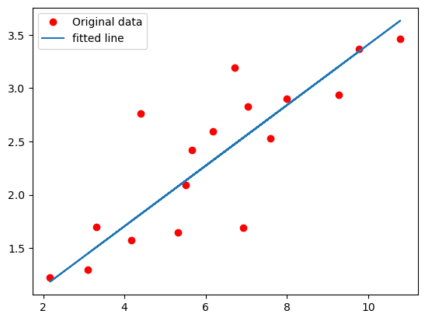

Lab 2

0.93

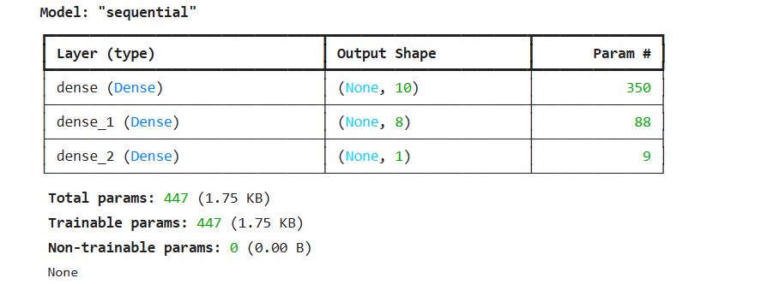

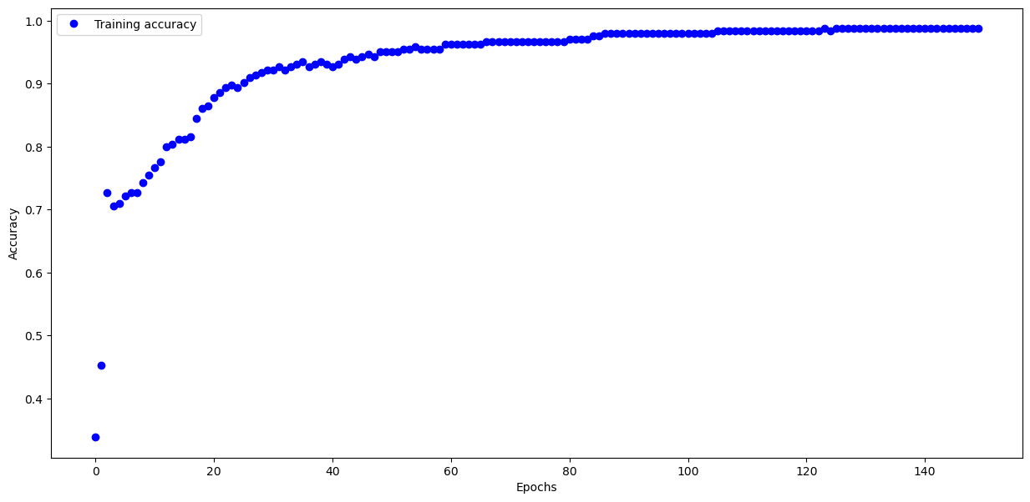

Lab 3

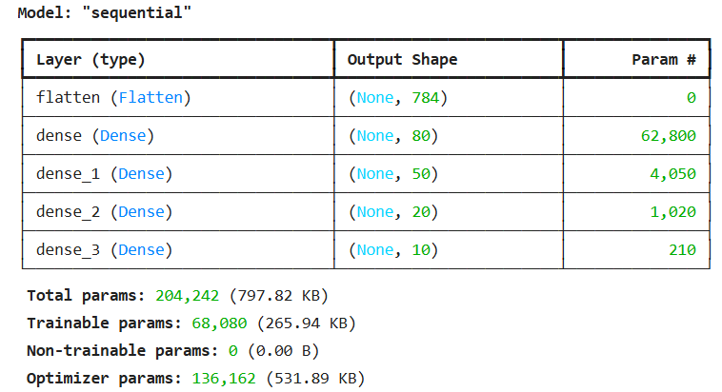

Test accuracy: 0.8870999813079834

Lab 4

Lab 5

Lab 6

Lab 7

Lab 8

Lab 9

Lab 10

Lab 11

Lab 12